Deflection of beams

Introduction:
The axis of the beam deflects from its initial position under action of applied forces. Accurate values for these beams deflections are sought in many practical case: elements of machines must be sufficiently rigid to prevent misalignment and to maintain dimensional accuracy under load; in buildings ,floor beams cannot deflect excessively to avoid the undesirable psychological effect of flexible floors on occupants and to minimize or prevent distress in brittle-finish materials; likewise, information on deformation characteristics of members is essential in the study of vibrations of machines as well as of stationary and flight structures.

Objective:
To investigate the support reaction forces and deflection of
- simply supported beam
- Cantilever beam.

Apparatus:
- UTM or Beam apparatus with movable knife frame(bending fixture),
- Vernier calipers, dial gauge, and a Tape measure. Calipers should be used to measure the width and thickness of the beam. Dial gauge will be used to measure the deflection of the beam. The tape measure is used to measure the length of the test region.
- Metal beam. The beam should be fairly rectangular, thin and long .Specific dimensions are dependent to the size of the test frame and available weights.

Theory:
Bending test is performed on beam by using the three point loading system. The bending fixture is supported on the platform of hydraulic cylinder of the UTM. The loading is held in the middle cross head. At a particular load the deflection at the center of the beam is determined by using a dial gauge.

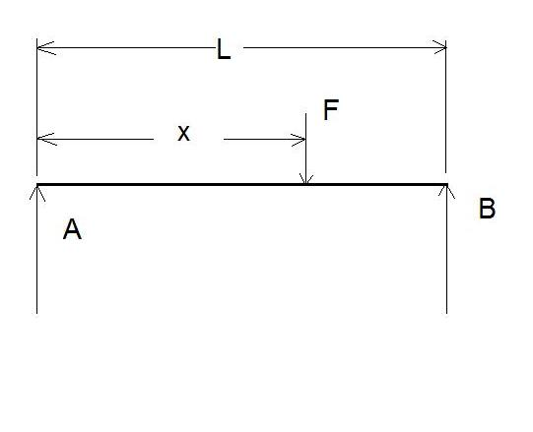
- Simply supported beam: In simply supported the 2 free ends of the beam are supported by knife edged supports of the loading frame and load is applied to a point X from the left support.

Above figure shows a simply supported beam of length L, (A, B) is the reaction forces and F is concentrated force acting at a distance X from A. The Reaction forces A and B are calculated using equilibrium equations ∑MB=0, and ∑MB=0.
Solving for support forces A and B, as in fig 1 we get:
A=F (1-x/l) & B=F(x/l)
The section between the load and the right hand support is symmetrical to this. The maximum deflection is at the center of the bar, where x=L/2 directly beneath the load.

- Cantilever beam:In a cantilever bar, one side of the bar is fixed and the other side free. The equation for the deflection y of the bar at the point of application of force is mentioned in the worksheet.
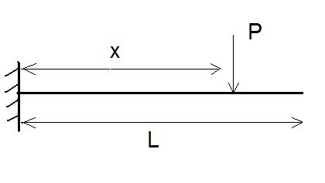
Above figure shows that a load P is acting at a distance x from the fixed end .The length of the beam being L. The support reactions being P itself since ∑F=0 in the vertical direction. The moment at the fixed end is given by
M=P.x (acting in the clockwise direction).
The influence of the length x for the deflection at the free end should be demonstrated in this experiment .For this purpose the force should be constant.

Procedure and Experimental setup
- for simply supported beam
- Set the knife supports at determined positions along the frame and mount the beam to be tested.
- The material, width, thickness, and length between supports should be measured and recorded for later use.
- Place dial gauges along lengths of the test area (the area between the knife supports) and set the gauges to read zero with no load applied (place any one dial gauge on the center of the simply supported beam to measure the actual maximum deflection)
- Adding the hook and hanger to the any preferred point of the beam (where the load P will be acting) at a distance X from right support or left support (in our case x is measured from left support), record the new readings for the gauges.
- Add new loads onto the hanger, recording the new deflections for each gauge after every loading and the support reactions are calculated by using eq 1.
- The theoretical deflection is calculated by using the formula mentioned in the worksheet provided.
- The comparison is done with the theoretical and actual deflections and Percentage error is calculated.
- for cantilever beam
- Mount the beam to be tested to the loading frame of the UTM with bending fixture at specified at appropriate point (for cantilever case)
- The material, width, thickness, and length between supports should be measured and recorded for later use.
- Place dial gauge at the center of the beam and set the gauge to read zero with no load applied.
- Adding the hook and hanger to the any preferred point of the beam (where the load P will be acting) at a distance X from right hand side or left hand side (in our case x is measured from the left hand side), record the new readings for the gauges.
- Add new loads onto the hanger, recording the new deflections for each gauge after every loading and the support reactions are calculated by using equation (mentioned above in the theory section.)
- The theoretical deflection is calculated by using the formula mentioned in the worksheet provided.
- The comparison is done with the theoretical and actual deflections and Percentage error is calculated.

Observation data:

- simply supported beam

- Material:…………...…………………………

- Critical dimensions:

L=………………….m (test length)
w=…………………m (width)
t= ………………….m (thickness)

- Positions of Dial gauge:

X1=L/2=………….m (at the center of beam)

- Position of Load acting:
X=……………………..m

- Deflection Data:
STEP | LOAD | GAUGE READING
Theoretical deflection at the center (as calculated eq in work sheet) =……………………….
Actual deflection at the center=…………………………….
% Error in actual reading (as compared to Theoretical) =……………………….

- cantilever beam

- Material:…………...…………………………

- Critical dimensions:

L=………………….m (test length)
w=…………………m (width)
t= ………………….m (thickness)

- Position of Load acting:
X=……………………..m

- Deflection Data:
SL. NO | LOAD | GAUGE READING

Theoretical deflection value (from worksheet) =…………………………..
Actual deflection at the free end=……………………………
% Error in actual reading (as compared to Theoretical) =……………………….

Extra Reading material:

http://www.scribd.com/doc/136561/Mechanics-of-Materials-Beam-Deflection-Test
http://nptel.iitm.ac.in/courses/IIT-MADRAS/Strength_of_Materials/Pdfs/5_1.pdf
http://www.clag.org.uk/beam-menu.html

Quiz:

- Which beam setup will deflect to the maximum from the original shape for the given load and beam dimension?
- Deflection of the cantilever beam is………………………
- Deflection of a simply supported beam is…………………….
- Deflection is directly proportional to………………….
- Deflection is inversely proportional to …………………………
- Moment of inertia for a circular section is given by ……………………
- EI = flexural rigidity. (T/F)
- The Maximum deflection for a cantilever beam when subjected to UDL is at the center (T/F)
- Moment of inertia for a rectangular section is given by I=bd^3/12 (T/F)

